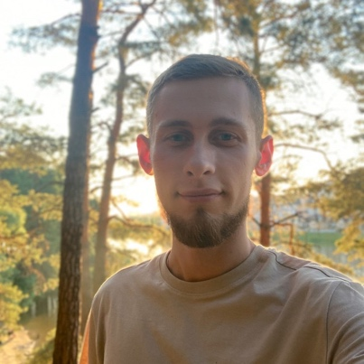
Resume from May 15, 2024
Zaiats Andrey Vitaliyevich

Senior Front-end developer (Vue.js)
Employment type: full-time
Birthday: August 24, 1997
City of residence: Kyiv
Phone number: +380956604639
Salary: $3500

Contact information
Email: andreyzaiats4@gmail.com

Work experience
Position: Middle / Senior Front-end developer
From 05.2022 until now (2 years)
NP DIGITAL, Ukraine
Creation of an admin tool for managers and employees of NOVA POST. Customization and supporting app modules for sending parcels from/to Europe.
Vue 3, quasar, unit tests, websockets, ci/cd, deploy, code review
Position: Middle Front-end developer
From 06.2021 to 05.2022 (11 months)
3k.group, KYIV
Creation of personal accounts and educational sites, a service for video conferencing. Working with vue.js(2,3), nuxt, docker, ajax, websockets.
Position: Middle Front-end developer
From 10.2020 to 02.2021 (5 months)
GMG, KYIV (Fintech projects)
Stack: Laravel Blade, JS, Vue, SCSS, BEM, JIRA, Webpack, NPM, GIT
Position: Front-end developer
From 03.2018 to 09.2020 (2 years 6 months)
Freelance, KYIV
- Creating adaptive and cross-browser layouts (BEM)
- Layouts for Laravel / Blade or CMS.
- Solving site optimization tasks.
- Implementation of JavaScript logic
- Creation of design for the site in the format of PSD layouts, banners.
- Development of invest. projects from scratch, admin panels and personal accounts.
- Development and support of the site of the Kiev tour operator (7 months)
Education
T.H. Shevchenko National University «Chernihiv Colehium»
Physical-math. faculty
Specialty: Teacher of computer science and english lang.
From 09.2014 to 06.2018 (3 years 9 months)
Additional education
Computer Academy STEP – JS courses (2018, 3 months)
Language proficiencies
- Russian ─ fluent
- Ukrainian — fluent
- English — intermediate
Additional information
I specialize in Front-end development.
Responsible approach to tasks, I bring the matter to the end. I like to realize that my work helps people and brings benefits. I always pay attention to the quality of the code so that it can be easily scaled and maintained. With each new project I try to improve my skills, I regularly study the latest technologies.
Мy portfolio and telegram:
https://avv4.github.io/
https://t.me/andrey4639

